merge conflict:
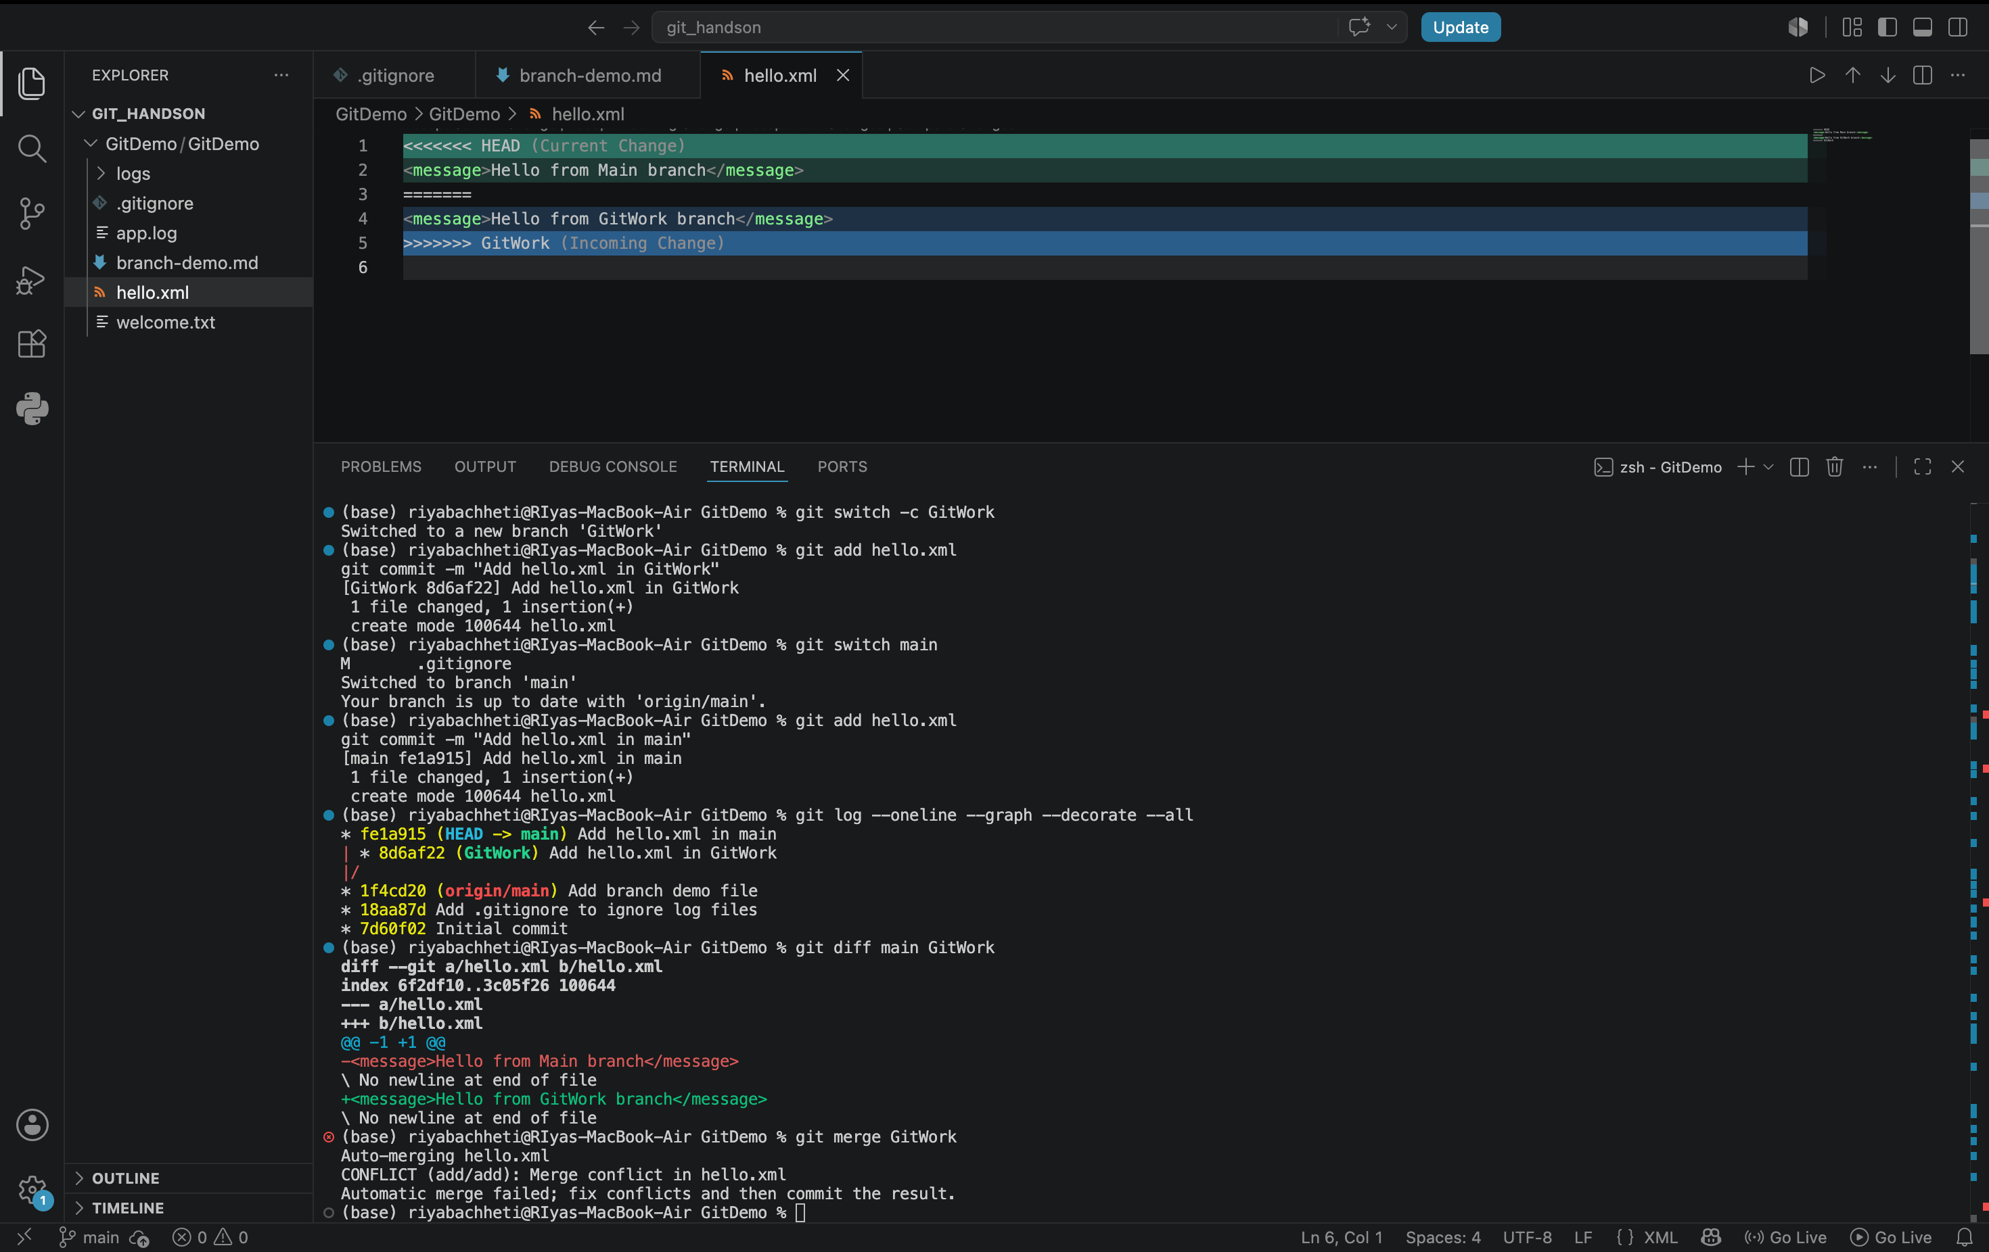

merge conflict resolved:
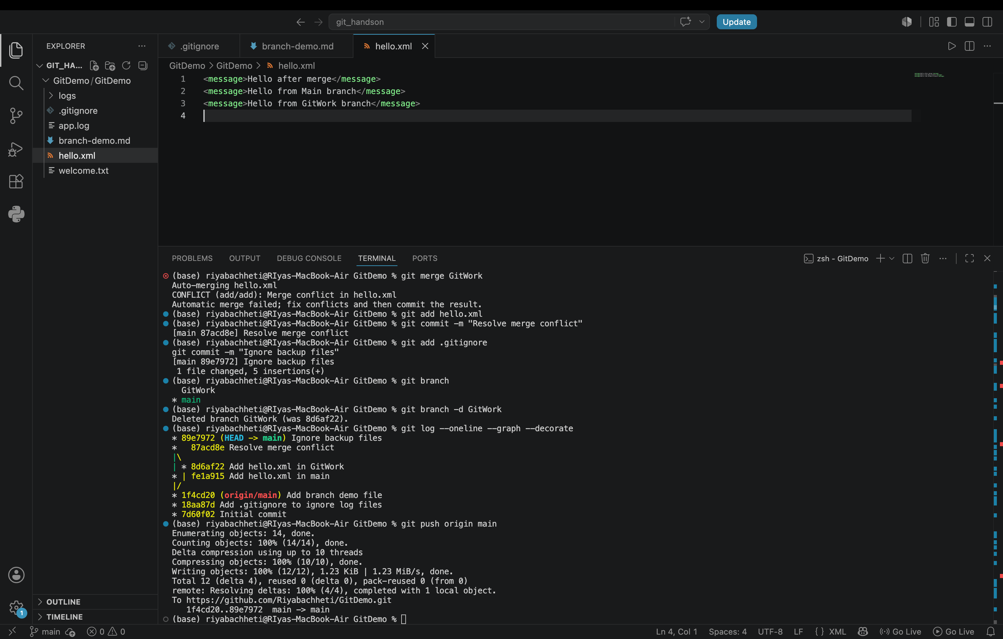

github repo: https://github.com/Riyabachheti/GitDemo.git

